MYTAXI SYSTEM

Use Case: <UC_001– LOGIN>

Version 0.1

Revision History

|  |  |  |  |
| --- | --- | --- | --- |
| Date | Version | Summary of Change | Author |
| 07 Jun, 2016 | 0.1 | Initial version | Tu Le  Nghi Phan  Phuong Do  Duyen Phan |

Distribution for Review/Approval

|  |  |  |  |  |  |
| --- | --- | --- | --- | --- | --- |
| Name | Title & Company | Issue Version | Issue Date | Review Date | Approval Date |
| Doan Vo | BA Lead - BAC | 0.1 | 07 Jun, 2016 | 09 Jun, 2016 |  |

Contents

1 Introduction 4

2 Processes 5

3 Flow of Events 5

3.1 Basic Flow: 5

Basic Flow: <Login by Third party> 5

3.1.2 Basic Flow: <Login with email> 6

3.2 Alternative Flows: 6

3.2.1 Alternative Flows: < Login by Third party failure> 6

3.2.2 Alternative Flows: < Login by Email failure> 6

4 Business Rules 7

5 Special Requirements 7

6 Supplementary Information 7

7 Related Documents 7

# Introduction

|  |  |
| --- | --- |
| ID and Name | UC_001 Login |
| Description | - Help user login this application with their personal information  - When user login system they will have their roles. |
| Actor | * Driver * Passenger * Admin |
| Relationships | Includes:   * Register   Extends:   * Forgot account * Manage acount * Manage route |
| Pre-conditions | 1/ Login account information are existing in DB  2/ Account Management function is completed |
| Post-conditions | User can access Account Management homepage after login successful |

# Processes

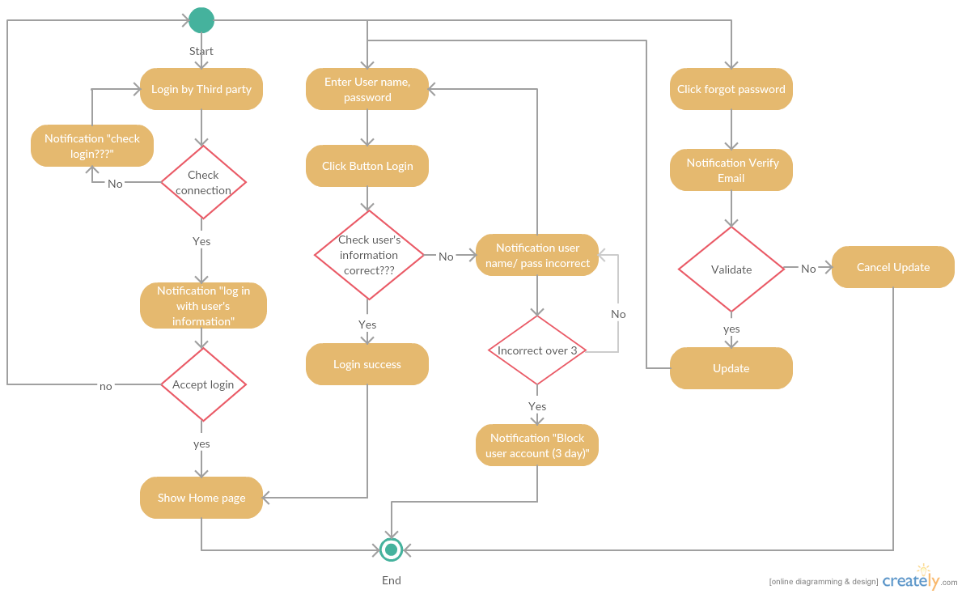

# Flow of Events

## Basic Flow:

### Basic Flow: <Login by Third party>

|  |  |
| --- | --- |
| **Step** | **Description** |
|  | The actor open application in his/her mobile |
|  | The Login page is displayed |
|  | Actor select a tool which use user their personal information to login |
|  | System launches the validation process |
|  | Actor accept login with personal information |
|  | Show Home page |

## 3.1.2 Basic Flow: <Login with email>

|  |  |
| --- | --- |
| **Step** | **Description** |
|  | The actor open application in his/her mobile |
|  | The Login page is displayed |
|  | The actor enter usename, password in textbox |
|  | The actor click Login button |
|  | System launches the validation process  + Checking that the actor’s email is/are existing in the DB.  + Checking that the actor’s password is/are existing in the DB. |
|  | The system displays the result of the validation:  + In case of successful, system displayed the “Account management” screen |
|  | * In case of successful,user login sucessful |
|  | The end |

## Alternative Flows:

### 3.2.1 Alternative Flows: < Login by Third party failure>

|  |  |
| --- | --- |
| **Step** | **Description** |
| 1 | At the step 3 of the Basic flow, Actor select a tool but not login |
| 2 | The system will desplayed “actor check login process with 3rd-party” |
| 3 | The actor login again |
| 4 | The end |

### 3.2.2 Alternative Flows: < Login by Email failure>

|  |  |
| --- | --- |
| **Step** | **Description** |
| 1 | At the step 4 of the Basic flow, actor entered invalid data and clicks “Login” button |
| 2 | In case error (Email or password incorrect): The system will displayed the Login page with the list of errors |
| 3 | The actor check errors, login again |
| 4 | The end |

# Business Rules

|  |  |
| --- | --- |
| **BR ID** | **Description** |
| BR1 | <Description, calculation logics, sample> |
| BR2 | <Description, calculation logics, sample> |
| BR3 | <Description, calculation logics, sample> |

# Special Requirements

<Only list out the non-functional requirements applied for this specific UC, not for the whole system. Normally it is performance requirement.>

# Supplementary Information

<Contain any additional materials that

* support to understand this use case better such as workflow, activity diagrams, data dictionary
* supplementary details for the completeness of this use case such as data specifications of entities used in the flows, message log
* golden data
* etc.

>

# Related Documents

<only needed if this document refers to many other documents, this section aims to give the readers a summary of all referenced documents>

|  |  |
| --- | --- |
| **When** | **Refer to** |
| <Purpose> | <Document ID – Name, storage location if possible> |